Transcript: NCTTE Procurement Supplier Briefing
31 March 2023
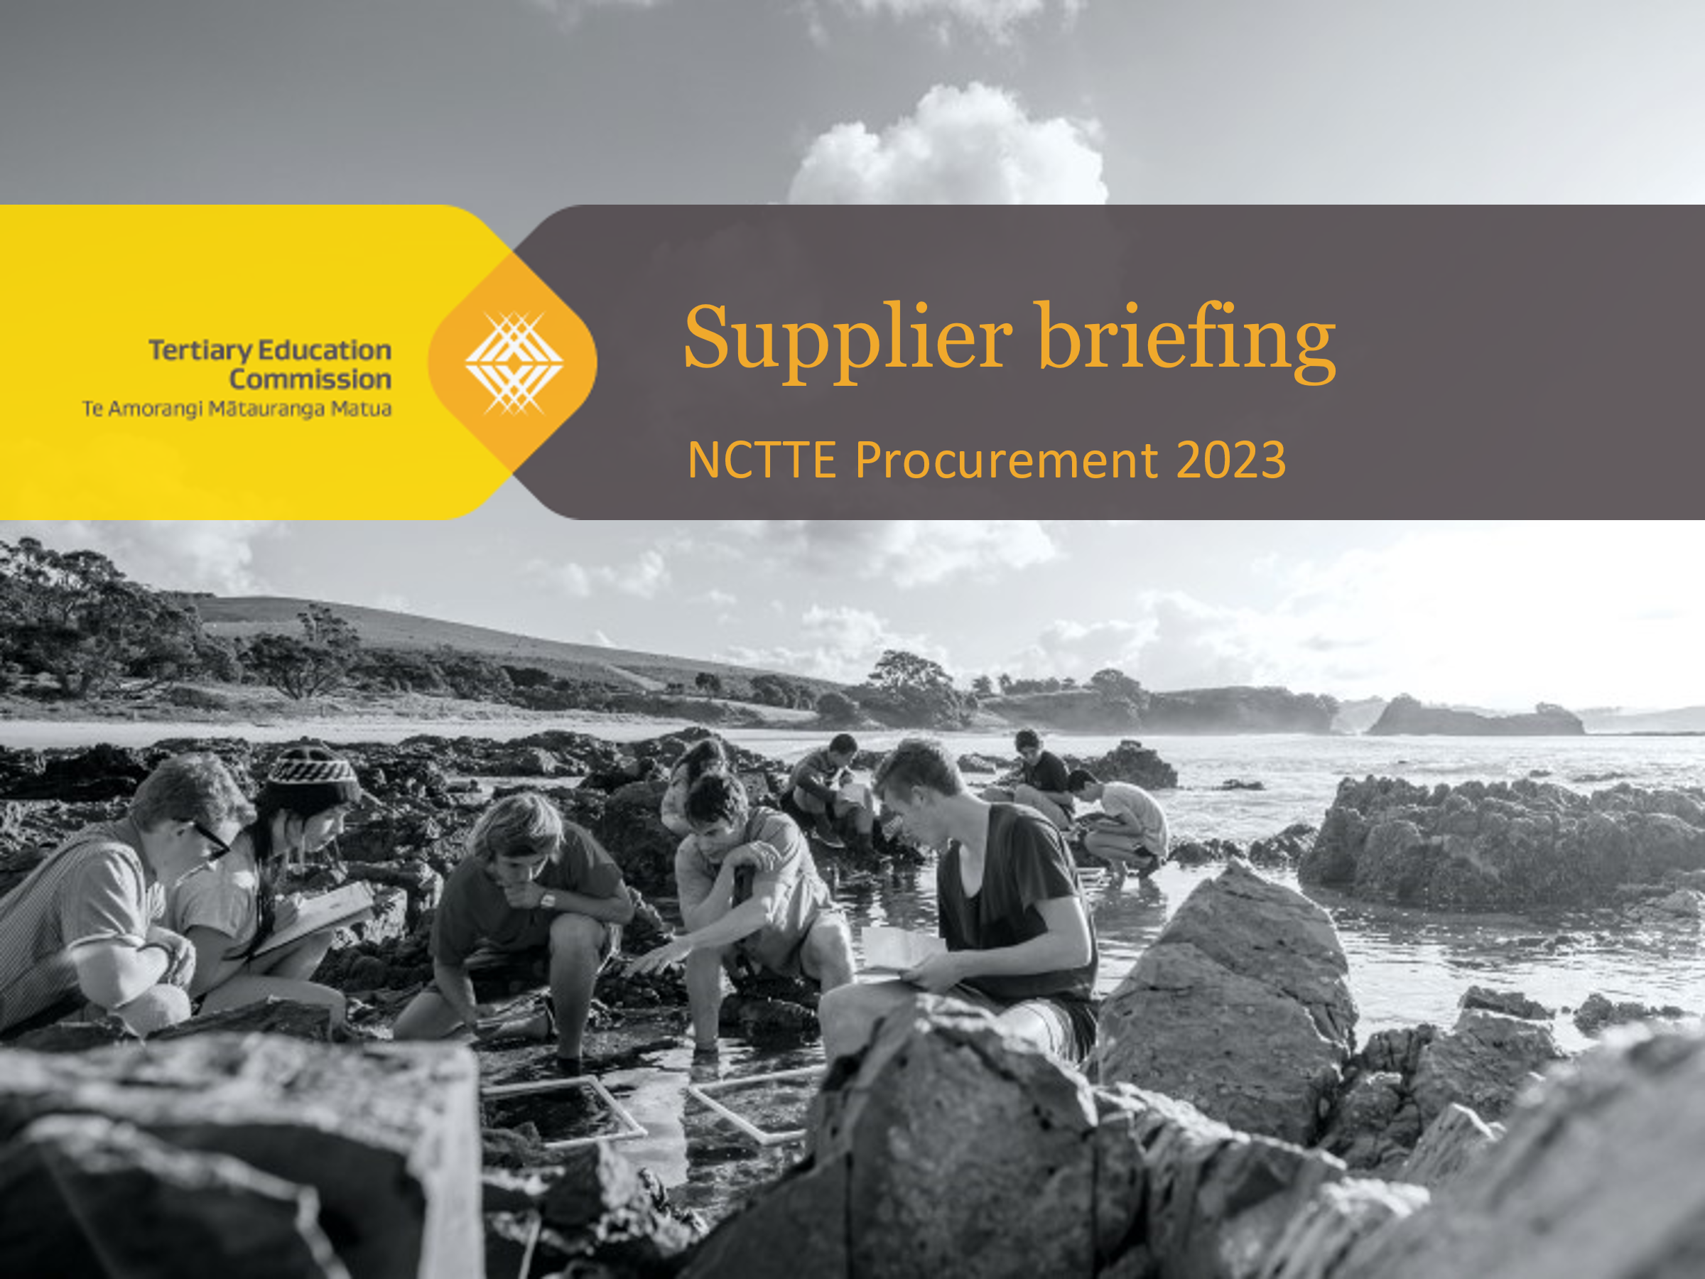
Morgan Healey: Kia ora koutou katoa. and welcome to the TEC's supplier briefing on the National Centre for Tertiary Teaching Excellence procurement. I'm going to kick us off with a karakia, and then I thought we'd have a few intros before we get into a very short presentation that we have pulled together. (And by we, I mean Nuran. Let's be honest, she's done all the heavy lifting here. So thank you, Nuran.)
Whakataka te hau
Whakataka te hau ki te uru
Whakataka te hau ki te tonga
Kia mākinakina ki uta
Kia mātaratara ki tai
E hī ake ana te atakura
He tio, he huka, he hau hū
Tihei mauri ora
Joseph Randall: Tihei mauri ora

Morgan Healey
So welcome again. Ko Morgan Healey tōku ingoa. I am the acting DCE in the Ōritetanga Learner Success team here at the TEC. I really want to thank you all for joining us this morning to discuss the NCTTE procurement process. We're going to keep this pretty high level and just run through some of the key points from the procurement documents which have been provided. It really is an opportunity for you to ask us questions, gain some insights and clarification on our expectations. So I'm going to hand it over to Joey and we're going to be playing a bit of tag team back and forth here this morning before we get to the questions. Joseph.
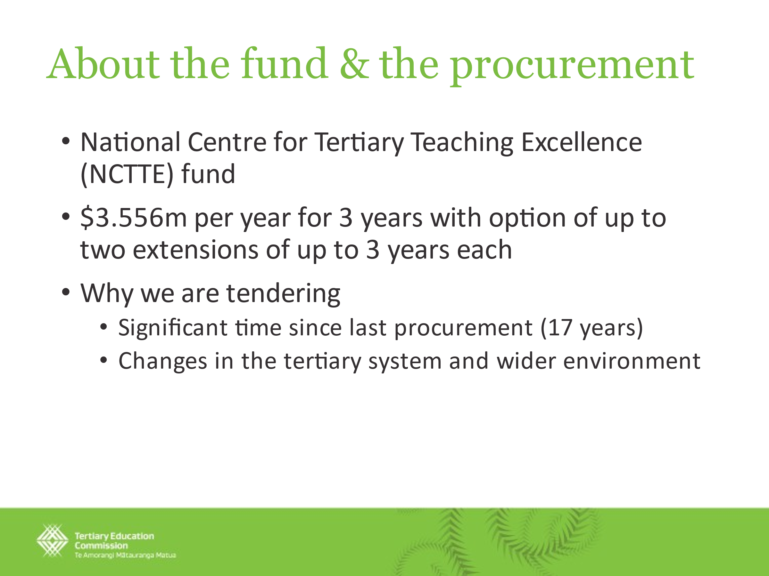
Joseph Randall
Thank you. Tēnā koutou, ko Joey tōku ingoa. I'm Joseph Randall. I am the Chief Advisor in the Careers and Investment Design directorate of TEC. The other thing just to note is this [supplier briefing] largely reflects the material in the procurement document, so hopefully none of this is a surprise. Again, we'll have questions as they come up.
We thought it would be useful to give a bit of background in terms of the fund and the procurement. So essentially, the National Centre of Tertiary Teaching Excellence Fund is about $3.5 million per year for three years and the procurement process that we're proposing is essentially a three-year initial contract with the option of up to two three-year extensions beyond that.
I think the important thing, and Morgan will talk about the specific criteria in terms of what the Centre does, but I think it's also useful to say why we’re tendering. The first thing is essentially this fund has not been tendered for the last 17 years. So in terms of the current funding approach that we've had, essentially we've been in a state where there's been contract negotiations through that period of time with the current hosts, but there hasn't been an external process in terms of advice around probity and just ensuring that we are essentially ensuring that we have gone to market. There is a process that's been recommended in terms of going externally that is in no way a reflection of the current host. So just to be really clear, this is about our internal cycles and tendering. This is not about anything to do with the current hosts.
The other thing though is there have been significant changes in the tertiary system and the wider environment in the last 17 years and particularly around more recently, the reforms around vocational education. We've in that period, had four different tertiary education strategies. There has been significant amount of shift in the system and so the other thing is really testing what and how the Centre focuses on the current environment, including the quite vastly different set up with the establishment of Te Pūkenga, for instance.
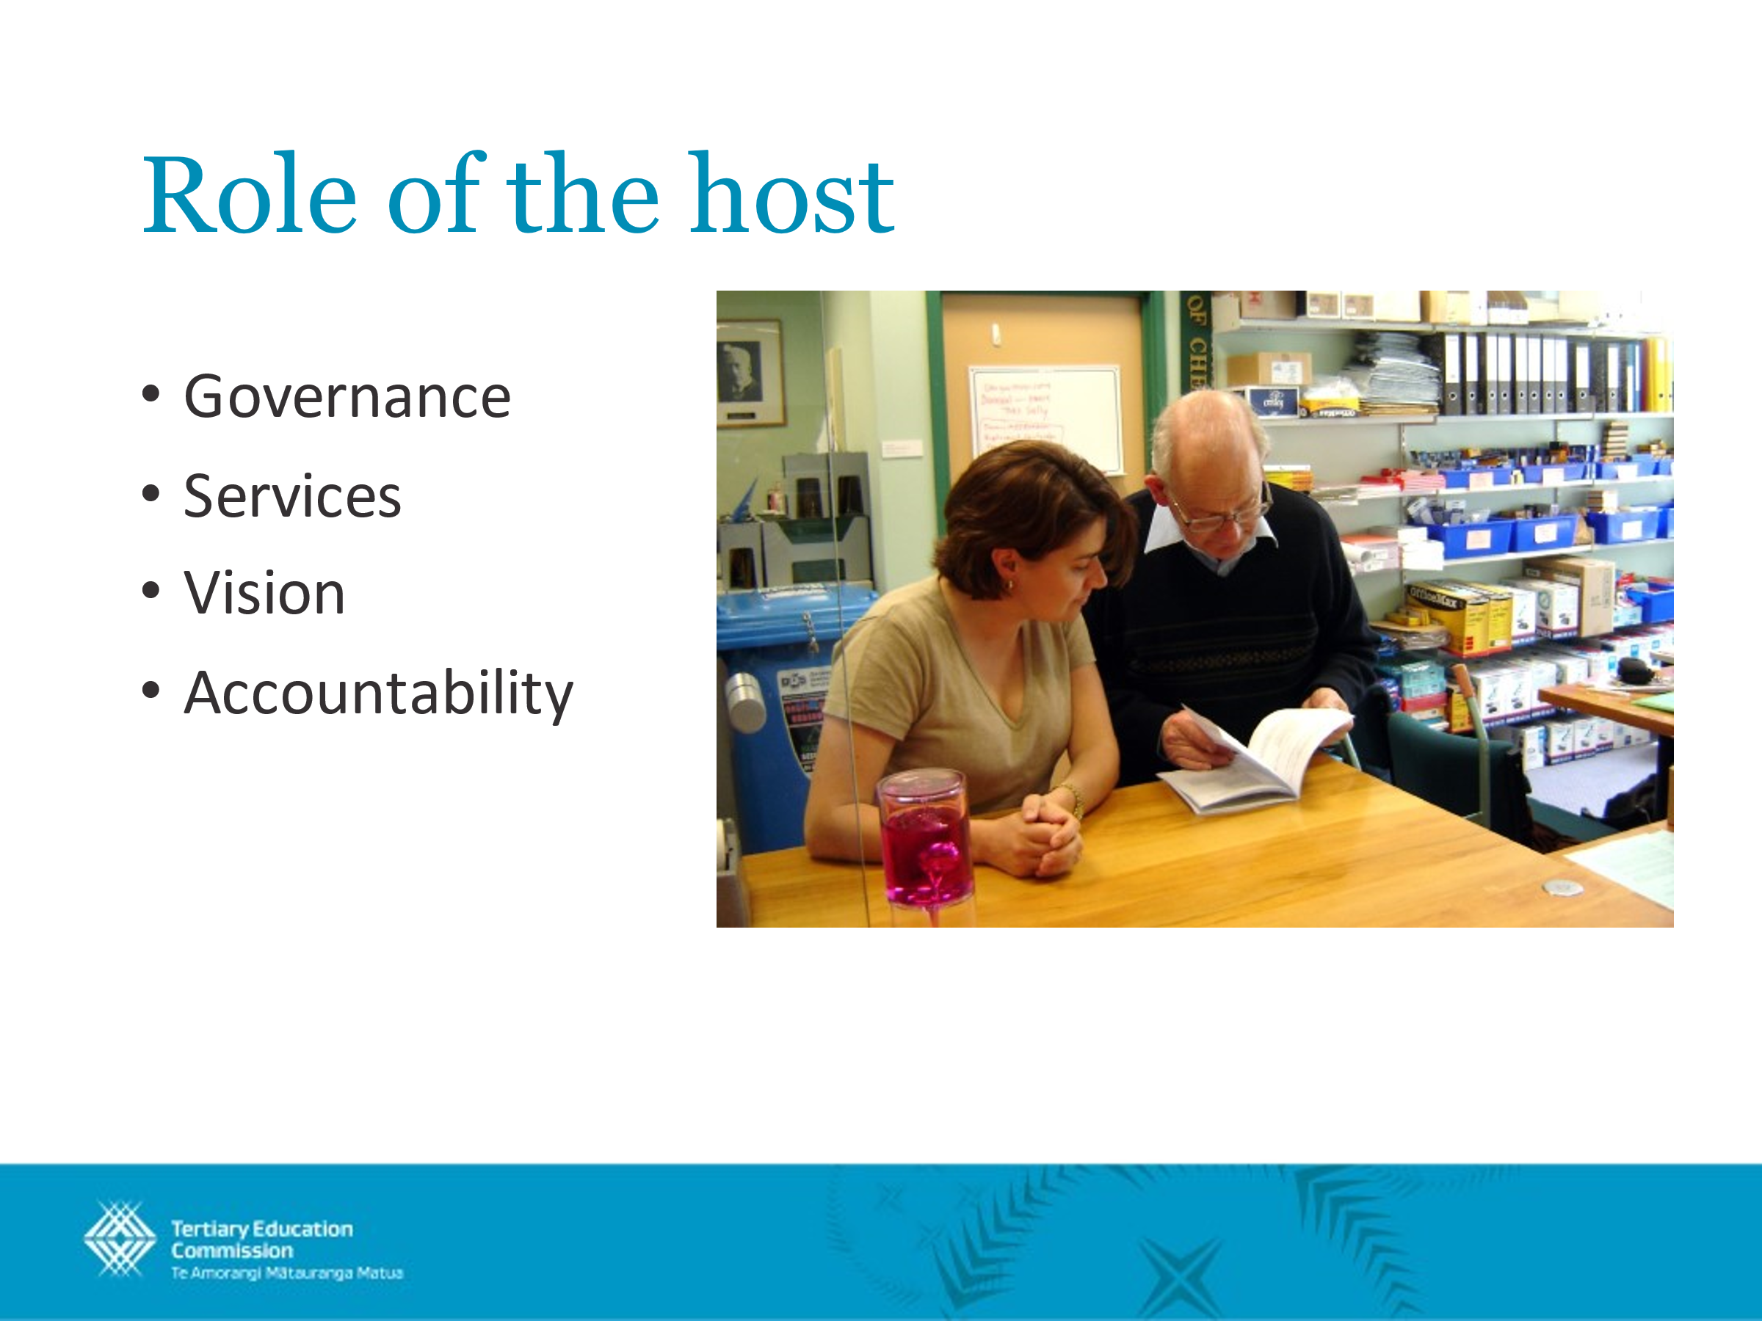
So these [descriptors on the slide show] the role of the host. These are gone into in more detail in the procurement document, but essentially it's important to note that the hosting institution or TEO has roles. The interesting thing that’s not here is obviously the establishment of the Centre. But the key roles in terms of the host itself is around governance; services ensuring the alignment and vision of the Centre; and those larger accountabilities. So essentially our funding contract, the Tertiary Education Commission’s funding contract, will be with the host institution and so the lines of accountability and oversight will be through that mechanism.
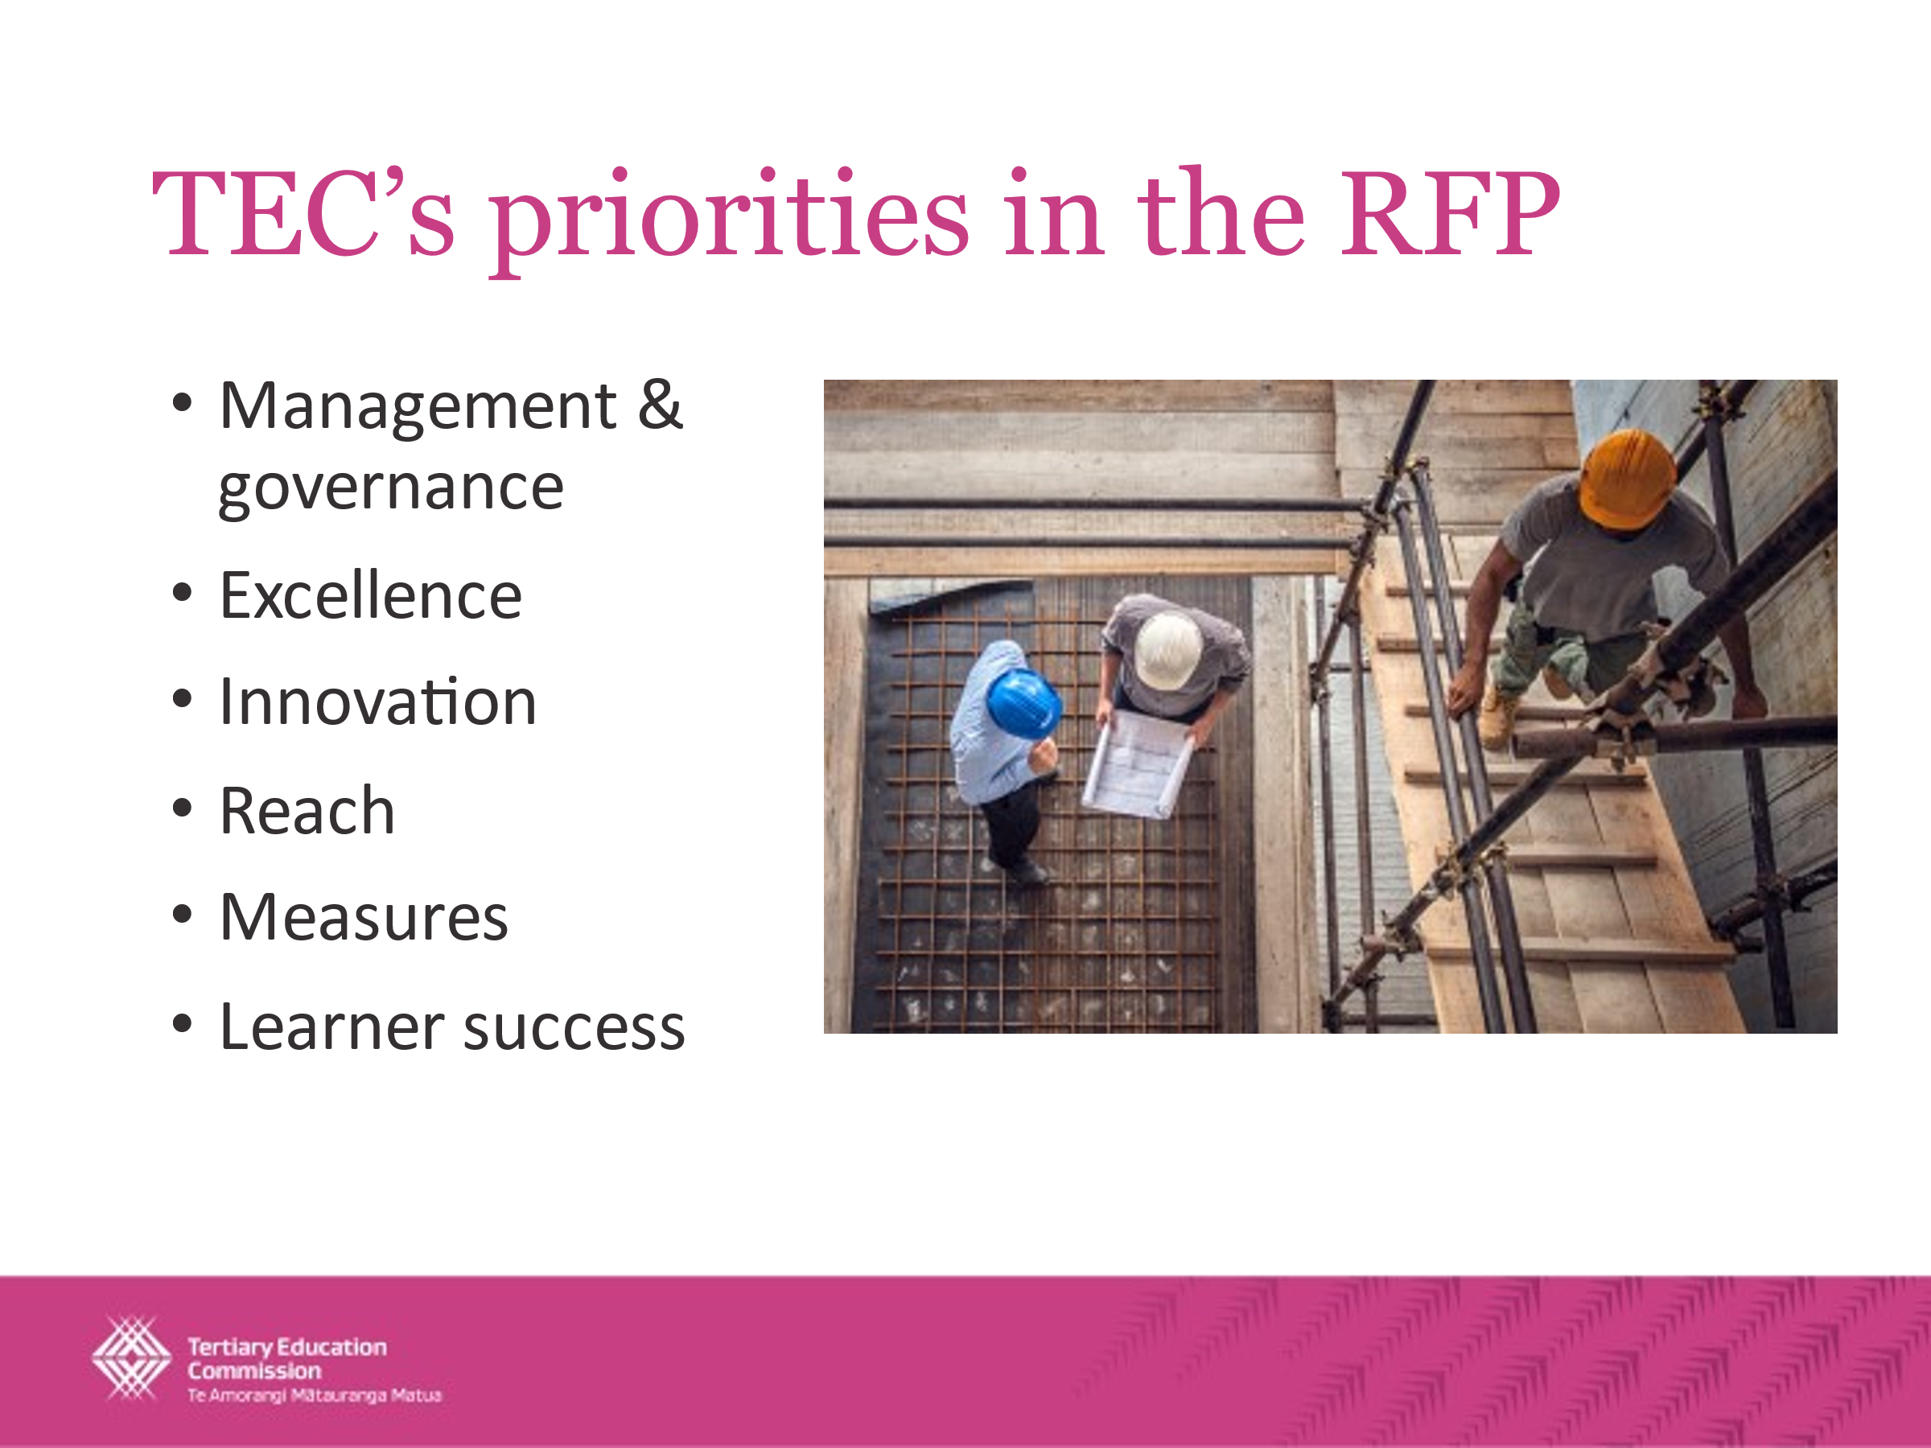
Morgan Healey
So, I'll pick up on the TEC priorities.
So Joey has given you a background and context for the RFP and the role of the host. I'm going talk you through our priorities, which will be key to our assessment of the proposals.
So the first one there [on this slide] is management and governance. So we expect applicants to evidence good self-management and are looking for strong governance models for NCTTE. One that balances and assures accountability without straying too much into any sort of co-management of the Centre alongside the actual management team whose role that is.
Excellence. So the Centre should aim to help New Zealand's tertiary education system develop excellence in its teaching capabilities. And I guess that for us that means working to make New Zealand an international stand out of excellent tertiary teaching.
Innovation. So the tertiary education system has changed significantly. And Joey, you know, spoke a little bit about that. I'll in the next slide talk a little bit more about that, but also at the same time, we do want to recognize this: the funds allocated to the Centre aren't a huge amount and they won't go as far as they may have done in the past. So we want proposals for a Centre that addresses these factors and offers some new solutions or new ways of working.
Reach. So this is about [the requirement that] the centre must be useful to the entire tertiary system, not a subset of TEOs or a subsector. So what we wouldn't want to see, for instance, is a centre that focuses almost entirely on foundation education and has few relationships or reach into the vocational or higher education system. We want something where PTEs, wānanga, Te Pūkenga, the universities and some of the other players in the system, like WDC's or RSLGs, are actually part of who the Centre reaches out to and engages with.
Measures. So we want to host who will develop a set of robust performance measures. I think this goes back to strong governance and management, where the governance is actually setting some really clear targets that then the management team or the senior leadership team is accountable to. And that helps us both as a funder and as a monitor as well, making sure that we all know what the goal is and having some key measurements that allow us to see how performance is actually tracking.
And then the last one is learner success. We've defined 7 key capabilities that we think are fundamental (and we've tested this with the sector) are fundamental to a whole of organization approach to learner success and really intentionally designing systems and processes and entire enterprises around learners and their whanau.
I think for me this is about two key things, (1) creating and nurturing communities of practice around learner success – so, sharing knowledge and insights, experiences to improve approaches to learner success across the network. You know, going back to the to the reach point.
And then also (2) driving up capability through things like professional development, development of resources and tools and guidance.
These the communities of practice and sharing knowledge really goes hand in hand with then producing resources around what is actually happening in the sector, what has worked and what hasn't.
So I will move on to the next slide.
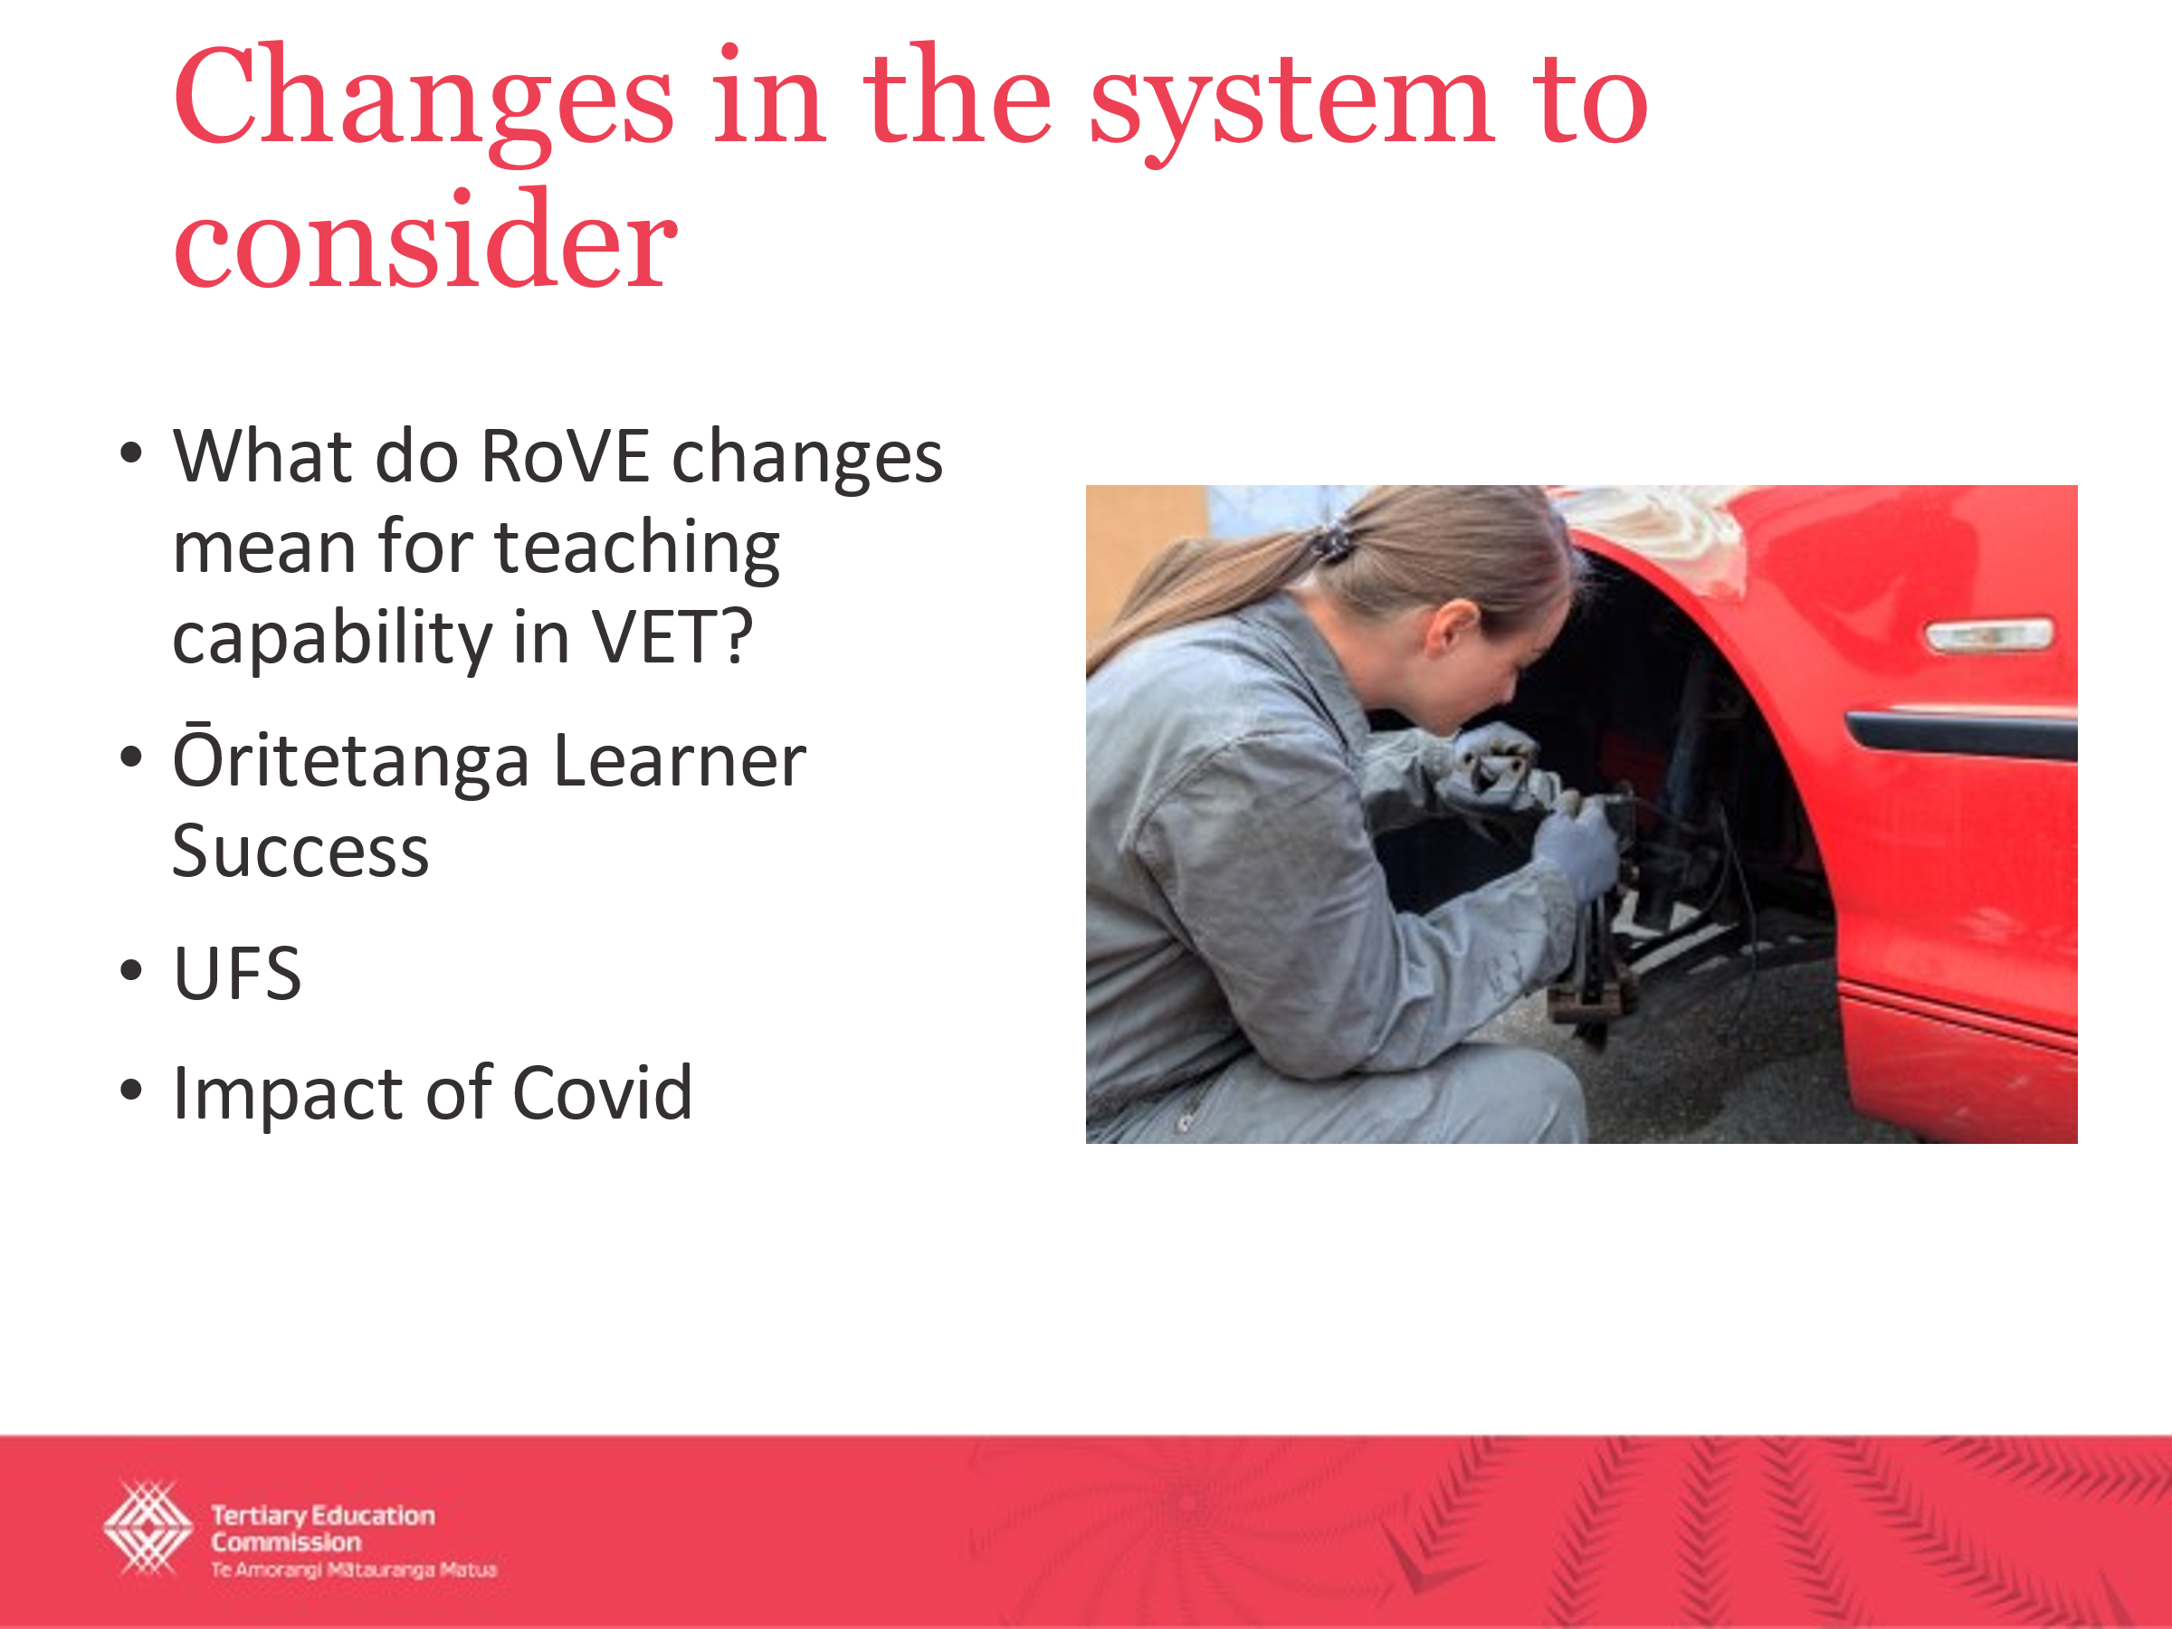
So all of this, I guess to Joey's earlier point, one of the impetuses behind going back to the market was there have been a lot of changes across the tertiary system in the last couple of years and we couldn't walk away from this session without talking about the Reform of Vocational Education. [This is a] once in a lifetime, 30 year – probably once in a 30 year type of change process that has really shifted how we think about vocational education and training (VET). What does it actually mean for the teaching capability across the VET, the VET system?
[Another] part of that [system change] obviously is the unified funding system and creating those seamless transitions for learners to move between different modes of delivery, [for example from] provider based through to work based and then back again.
Ōritetanga Learner Success. Our Board is laser focused on shifting the dial around equity and the system’s underperformance when it comes to Māori, Pacific and disabled learners, and people that are first in family [to go to tertiary study] from low socioeconomic status. Our board is really, really and our executive leadership team is really focused on how do we build the capability of the system to actually deliver on equity.
And then [there’s] the impact of COVID and I would also add to that, the Cyclones in the North Island in the last few months. We've already heard from the sector around lost learning.
As the results of particularly COVID and the barriers were – the difficulties that creates for learners transitioning from senior secondary through to the through to tertiary.
All of these are factors that the Centre can offer [TEOs help in addressing] in terms of how do you support the system to either achieve something like learner success or the outcomes sought through the reform of vocational education or help us to mitigate the ongoing impacts that COVID and things like natural disasters like cyclones have precipitated.
Next slide please.
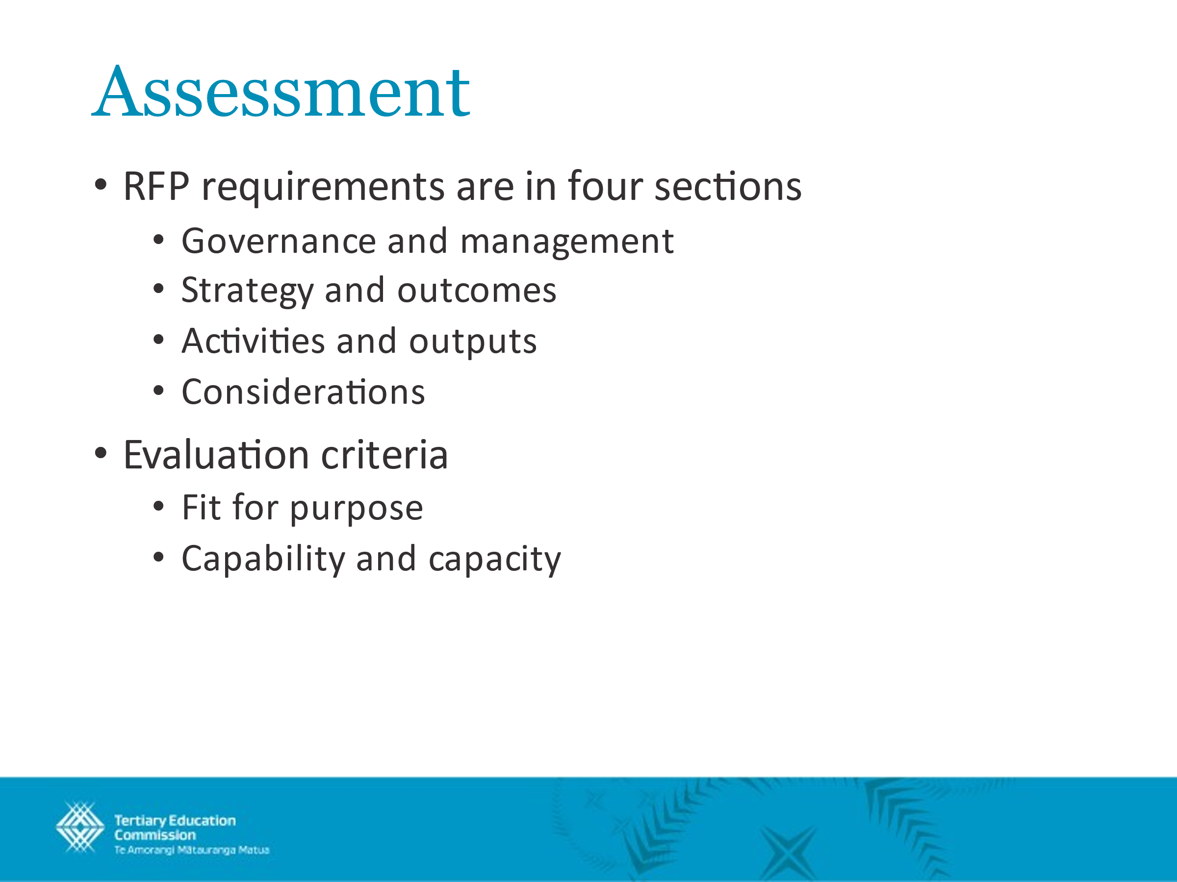
So I'm just going to briefly talk about our assessment process. The detailed requirements and evaluation questions are already in the RFP, so I'm not going to go into too much detail here.
But the RFP requirements, they tell you what we need from the centre and how you could demonstrate that in your proposals. So governance and management, we've kind of covered this previously, but the centre must be well run, committed to Te Tiriti o Waitangi principles and obligations and provide some value for money.
Strategy and outcomes. So the aim and overall strategy must be set to make the difference we want the centre to facilitate. I've briefly just touched on some of those [priority goals] – the tertiary education strategies [is] obviously a key driver for us and the reforms of vocational education and Ōritetanga Learner Success are key enablers or activities that we are doing to actually implement those and to hopefully support the rest of the system to implement the Tertiary Education Strategy.
Activities and outputs. So what the centre will do to deliver on the strategy. And then considerations: these are aspects of the proposal that we will factor in to our assessments, but where our expectations may be a bit more fluid.
Evaluation criteria: we've kind of put those under 2 headings. Fit for purpose: will the centre you propose help the sector as intended. Capability and capacity: that's our confidence that you can deliver the centre envisioned.
Right. So now we have come to the very important [part of this session]. I did say we'd be brief, and we have been. So I’d like to open up the floor for any questions.
Joseph Randall
At, there's a question in the chat from Helen and apologies, we normally would respond in terms of the chat but because this has been recorded we thought it would be useful to discuss it directly. So Helen’s question is, was the Ministry of Education involved in developing the RFP, were they notified that the TEC would undertake this process.
The answer is yes in two parts. So the first part is obviously the Ministry of Education develops, for the minister’s approval, the funding mechanism for the National Centre of Tertiary Teaching Excellence, which determines how the TEC is able to fund and what the funding is for. So they lead that process. More directly, they were notified in terms of that we've been undertaking this process and the general approach and timeframes.
Morgan Healey
Sakinah.
Sakinah Tuan Besar
Right. Hi, I'm Sakinah from University of Canterbury. I wanted to know whether, for all the cover of the whole sector, I was just wondering if the centre is expected to also support non government funded for TEO or is it just for government funded ones?
Morgan Healey
Ah.
I don't – I’m going to take a punt at this. We probably need to just confirm, but my expectation would be that the centre is for any organization or you know provider that delivers teaching and learning across the tertiary system and Aotearoa. Obviously you know one of our key roles at the TEC is investor and we have you know specific providers that we invest in. But I wouldn't see why the centre would make a distinction between those that the TEC funds and those that are funded through other means.
Does anybody else – have any TEC people any other thoughts on that?
Nuran Cinlar
No, I think you really captured it. The language in the funding mechanism really stressed that the NCTTE is there to help anyone in New Zealand who is providing tertiary education.
Morgan Healey
Perfect. Thank you, Nuran.
So Helen has another question. Uh, which I'm just going to read out. The RFP refers to 3 times 3 year contract if successful. Will the fund level be reviewed with the ministry over this time frame and inflation adjustments considered? I actually don't know the answer to that, but Nuran do you? Yes, thank you. OK.
Nuran Cinlar
I'll take a punt at it. The ministry has its own timeline for when it reviews various funding mechanisms. We have visited this question periodically through the 17 years and TEC can raise it again. But what the ministry does is really going to be the ministry's decision.
Joseph Randall
Well, more than that. I mean, I think we need to be open to have ongoing conversations about the funding and what is possible in terms of the funding amount to be delivered within that.
The challenge, to be really clear, is this is a Budget decision. So this is not just the Minister but a Cabinet Budget decision. And so I think we can undertake to have ongoing conversations about appropriate levels of funding, but the ultimate decision is essentially whether or not this is a budget priority and how that reflects that in the amount of funding is that is allocated on this mechanism.
Morgan Healey
To connect to you have another question.
Sakinah Tuan Besar
Yes, I do.
Morgan Healey
No.
Sakinah Tuan Besar
I have taken a look at the current centre’s I guess annual report, and I was just wondering, they would have other sets of revenue coming in besides the NCTTE fund. So I was just wondering what is the expectation for the new center? Should the new center carry out the other sets of activity because they receive other sets of funding as well, for example like the TEC adult teaching courses or TDEA scholarship. Something like that. Is that, what would be your expectation on that?
Joseph Randall
To be really, really clear, those are separate contracts, so this procurement process is just for this [NCTTE] funding and the requirements set out in terms of this funding. Other contracts for other services that the TEC tenders are not related. So that's not to say that if there were other sources of revenue that it would, you know, it would be outside of the scope to put those together, but they are completely separate procurement processes.
Morgan Healey
Anybody else?
Joseph Randall
Are there any other questions?
Helen Lomax
Kia ora it’s Helen. I do have a question. This might be somewhere in the document, so forgive me if I have missed it. Is there a chance to actually present and talk to it [our proposal] or is it just a paper-based exercise?
Morgan Healey
I believe – and please correct me if I'm wrong – at this point it is just a paper based exercise.
Nuran Cinlar
Right. We have the tentative date that, if we wish to or need to, we will invite bidders to come and present to us. But we're unsure at this point whether that is going to be necessary. So there is a date somewhere in the list of deadlines for that potential presentation.
Morgan Healey
Thank you.
Helen Lomax
OK. So I'll just have a look through the documents again, OK.
Morgan Healey
Anybody else?
Sakinah Tuan Besar
I might have a silly question. I'm just looking at the timeline, and the timeline for April and that would be a lot of holidays, school holidays or public holidays. Is there any chance that the dateline might be pushed out? Just because, I guess, accommodating a lot of the public holidays happening in April? Is there any chance for it actually?
Morgan Healey
My understanding is no, that we are looking to keep to these timelines.
Anybody else? Right. Well, if there are no further questions, I might hand over to Joey to do the Karakia to close this out.
Joseph Randall
And also to thank you all for your participation. As it says in the presentation and in the procurement documents there are contact details for us if you have any further follow up questions and we will obviously distribute those answers to everyone, so everyone is getting the same information.
Right and Kia hora te marino. Kia whakapapa pounamu te moana. Hei huarahi mā tātou i te rangi nei. Aroha atu, Aroha mai. Tātou i ā tātou katoa. Hui e! Tāiki e!
Morgan Healey
Thank you everybody.
Helen Lomax
Thank you.
Joseph Randall
Thanks.
Morgan Healey
Have a lovely weekend.
Helen Lomax
Ka kite

