DXP Ngā Kete transition: Add and update MoP data in DXP Ngā Kete
The process to add and update MoP data, and to upload MoPs has changed. DXP Ngā Kete will not accept MoPs uploaded in their existing Excel formats.
DXP Ngā Kete supports two new options to create and edit your MoPs depending on their size and complexity and your existing processes for preparing MoPs.
Option 1: Manually enter data into the MoP template webform in DXP Ngā Kete.
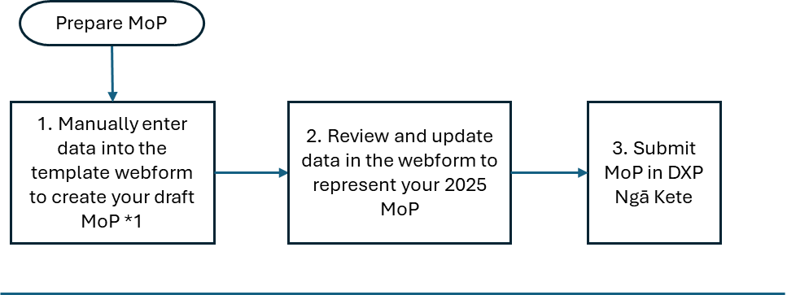
*1 this may be your 2024 MoP data to use as a starting point or your first draft 2025 data.
Notes:
- There are changes to some MoP data requirements – Data Requirements – Data System Refresh | TEC website
- Calculated fields will update automatically as you enter data into the webform, and a running total along with any variance against the funding allocation will display at the top of the screen.
- This option is suitable for small MoPs (say 15 rows or less) where it is quicker and easier to enter data in step 1 than entering the data into a workbook for upload in csv file format. Instructions for the upload file option are outlined below.
- In future years you will be able to either manually enter you draft MoP data (as described here) or use your prior year MoP in DXP Ngā Kete as to create your draft MoP.
Option 2: Upload prior year MoP data as the starting point for the new draft MoP
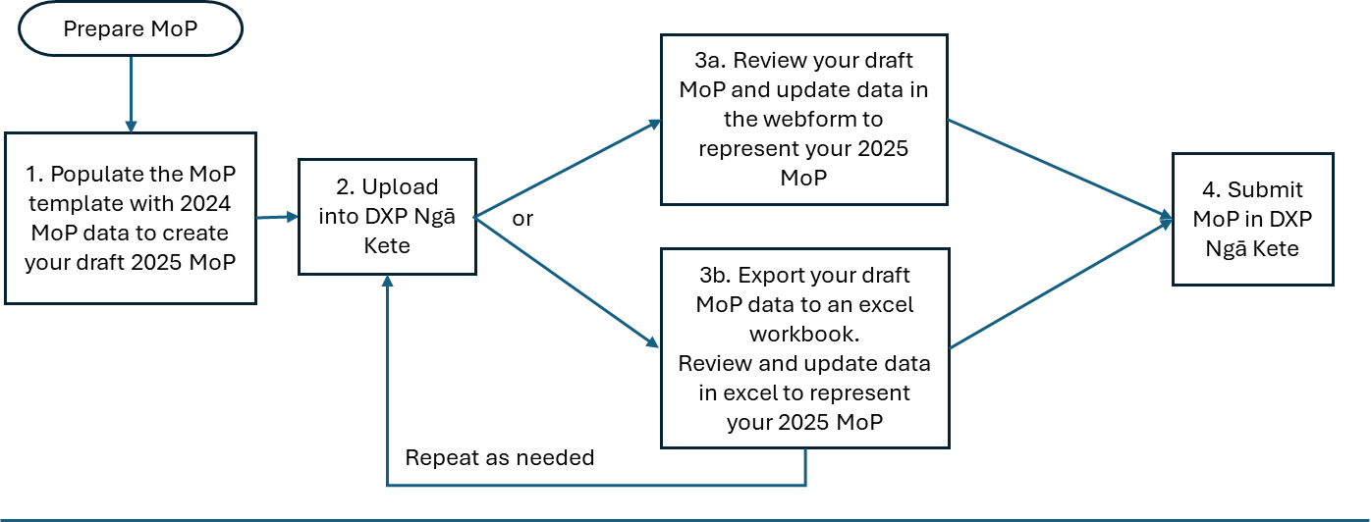
Notes:
- There are changes to some MoP data requirements – Data Requirements – Data System Refresh | TEC website
- Calculated fields will update automatically as part of the upload process, or as you amend data in the webform, and a running total with the variance against the funding allocation will display at the top of the screen.
- A variation to Option 2, step 1 is to populate the MoP template with data from your source system (e.g. a forecasting system - if this is your existing process to prepare MoP data).
1 - Populate the MoP template:
This is a one-off activity needed this year to transition DXP Ngā Kete. Next year and going forward you have the option to use your prior year MoP submitted in DXP Ngā Kete to create your initial draft MoP.
Here are step-by-step instructions to populate your first MoP template.csv using 2024 data.
- Select your MoP in DXP Ngā Kete, click ‘Start & validate submission’ and download the MoP template.csv.
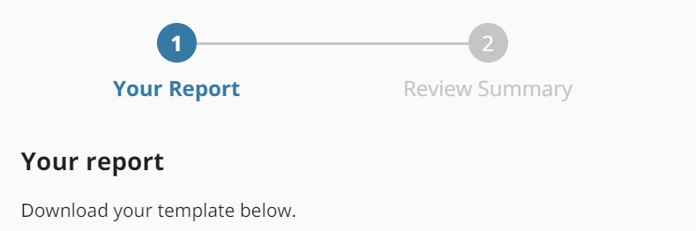
Template name- Mix of Provision -template.csv.

- Open your 2024 MoP with data to copy into the new MoP template.csv.
  - First, Copy, paste special, values the data from the 2024 MoP (including the column headings) into an empty Excel workbook.
    - If the 2024 MoP was by Territorial Authority (as well as Region), you will need to summarise the data to just Region-level. You can do this using pivot tables.
- Then, copy and paste the MoP data into the relevant columns in the new template.csv downloaded in (1).
- Save your worksheet as <filename>.CSV UTF-8.
2 - Upload into DXP Ngā Kete
- file and follow prompts to upload your csv file.
3a – Review data and update in webform
- Click Add row or Edit row and follow online prompts to update MoP data, or
3b – Review data and update in using Excel
- Export the draft MoP in DXP Ngā Kete into an Excel workbook and edit. Here are step-by-step instructions.
  - Go to the Data submission Version history, click onto the draft MoP submission you created in step 2.1) and click ‘Export’;
Note that the download will include calculated columns. You do not need to remove these columns.
  - Make edits as needed using Excel functionality
    - You can use space to the right for your workings. Anything to the right of the prescribed columns will be ignored by the upload process.
    - You may need to Download your list of qualifications to access relevant qualification data.

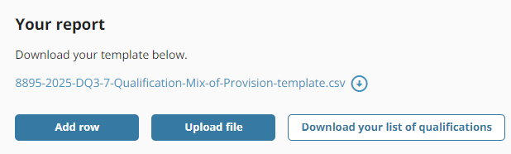
  - Save as <filename>.CSV UTF-8
- Upload into DXP Ngā Kete
  - Click Upload file and follow prompts to upload your csv file. Note that this format of the csv file, including the calculated field columns will be accepted by DXP Ngā Kete. Any data in the calculated fields will be disregarded as the calculations will re-run as part of the upload process.

Modelling data in Excel:
If you currently use Excel to model your MoP data prior to submitting, we may be able to provide assistance. Please email customercontact@tec.govt.nz using ref [EDUMIS No] - DSR.
Going forward, it will be your responsibility to update and maintain any Excel workbook you use for modelling MoP data. Reference data you will need is provided via DXP Ngā Kete and on the TEC website.

